Home Control System Paperwork

Dr. Kalaiselvi K  
Department of Networking and Communications, Faculty of Engineering and Technology,  
SRM Institute of Science and Technology, Kattankulathur, Tamil Nadu-603203, India  
Email: gxr02005@gmail.com

# Abstract:

Home automation systems have become an increasingly important area of development, driven by the rising demand for energy-efficient and remotely accessible solutions for residential settings. This paper presents a practical and scalable approach to smart home automation using an ESP32 microcontroller integrated with a two-channel relay module for controlling essential appliances such as a fan and a bulb. The proposed system facilitates real-time monitoring and control via Wi-Fi, allowing users to operate appliances remotely through a web interface or mobile application. This enhances convenience, safety, and energy efficiency in everyday household operations.

The system leverages embedded Wi-Fi capabilities of the ESP32 to establish seamless wireless communication between the controller and the user interface, offering low-latency switching and feedback. The two-channel relay provides a compact yet flexible solution to control multiple appliances, and the modular architecture allows easy expansion to more devices. Designed with cost-effectiveness and ease of deployment in mind, the system is suitable for both new and retrofit installations. Extensive performance evaluations were conducted in real-life scenarios to assess system reliability, responsiveness, and user-friendliness. The results confirm that the proposed smart control system offers robust and efficient operation, with strong potential to serve as a foundation for more comprehensive home automation frameworks.

Keywords:** Home Automation, ESP32, Relay Module, Fan Control, Bulb Control, Wi-Fi, Smart Home, Remote Switching, Energy Efficiency, IoT, Real-Time Monitoring

# I. Introduction

Home automation represents a major shift in how individuals interact with and manage their living environments. Traditional methods of manually operating switches are increasingly being replaced by smart systems that offer remote control, automated responses, and seamless integration with other digital technologies. The concept of a home control system, once considered a luxury, is now within reach due to the affordability and accessibility of Internet of Things (IoT) devices.

The ESP32 microcontroller, with its built-in Wi-Fi and Bluetooth capabilities, has opened new doors for developers and hobbyists alike to create intelligent, networked home automation systems. This paper focuses on a simple yet powerful application of the ESP32 combined with a two-channel relay module to control two appliances: a fan and a light bulb. The system aims to demonstrate the effectiveness of smart control using real-time web-based interfaces and highlights the benefits in terms of energy savings, convenience, and flexibility.

The following sections detail the background research, technical methodology, hardware and software implementation, testing procedures, evaluation metrics, and the potential for future enhancements and scalability of the system

# II. Related Works:

The evolution of smart home systems has been closely tied to developments in embedded systems, wireless communication, and IoT technologies. Numerous researchers have proposed and implemented systems using microcontrollers such as Arduino, Raspberry Pi, and ESP8266.

Early implementations primarily focused on automation through infrared remotes or Bluetooth modules. These were limited in range and lacked real-time feedback mechanisms. More recent projects have embraced the capabilities of Wi-Fi-enabled microcontrollers, especially the ESP32, due to its superior processing power and integrated connectivity features.

For example, Kumar et al. (2021) implemented a lighting control system using the ESP8266 and Blynk, enabling users to switch lights on and off via a mobile app. Similarly, Sharma and Patel (2020) designed an ESP32-based system that integrated temperature and motion sensors for dynamic environmental control. These systems illustrated the convenience and utility of smart home systems, but often lacked robustness, multi-device control, or fail-safe mechanisms.

Our proposed system builds on these efforts, integrating web-based controls, status feedback, and low-power operation. It provides a foundational structure that is both adaptable and extendable, catering to a wider range of domestic needs.

# III. Methodology

**3.1 System Design and Architecture  
The system design prioritizes user-friendliness, reliability, and ease of deployment. It consists of:**

* **An ESP32 microcontroller serving as the central control unit.**
* **A two-channel relay module for appliance switching.**
* **A fan and bulb representing the controllable devices.**
* **A Wi-Fi-based dashboard accessible from smartphones, tablets, or computers.**

**The architecture supports both automatic and manual control mechanisms. Users can interact with the system through a local web interface that visually represents the status of each connected device and provides control buttons for toggling power states.**

**The system is designed to operate on a local network, ensuring security and quick response times. It is also capable of being expanded into cloud-based architectures with minimal modification, allowing control from remote locations.**

**3.2 Hardware Components and Connections  
The image below illustrates the basic wiring layout between the ESP32 and the two-channel relay module connected to a bulb:**

***Fig 1. Wiring diagram for ESP32 and 2-channel relay module controlling a bulb.***

* **ESP32 Microcontroller: Provides the computational and communication capabilities. Configured via the Arduino IDE, it interfaces with the relay module using GPIO pins.**
* **Relay Module (2-Channel): Acts as an electrically operated switch. It receives signals from the ESP32 and toggles the connected appliances accordingly.**
* **Fan and Bulb: Standard home appliances wired through the relay module.**
* **Power Supply: Ensures consistent voltage and current to all components.**

**The wiring follows basic electrical safety norms, ensuring that high-voltage appliance control is isolated from the low-voltage microcontroller circuitry.**

**3.3 Software Design and Web Interface  
The ESP32 is programmed using C/C++ within the Arduino IDE. The embedded firmware handles Wi-Fi initialization, server setup, GPIO management, and response to HTTP requests.**

**The web interface is a minimalist HTML page with ON/OFF buttons for each appliance. JavaScript is used to send commands asynchronously to the ESP32, and the current state of the appliances is displayed in real-time.**

**3.4 Control Flow and Logic**

1. **Upon startup, the ESP32 connects to the configured Wi-Fi network.**
2. **It initializes GPIO pins and begins hosting a local web server.**
3. **Users access the ESP32's IP via browser and interact with the web page.**
4. **Button clicks trigger HTTP GET requests (e.g., /fan/on, /bulb/off).**
5. **The ESP32 parses the request and switches the corresponding GPIO pin HIGH or LOW.**
6. **The relay module receives the signal and toggles the power supply to the connected device.**
7. **Status feedback is updated on the webpage.**

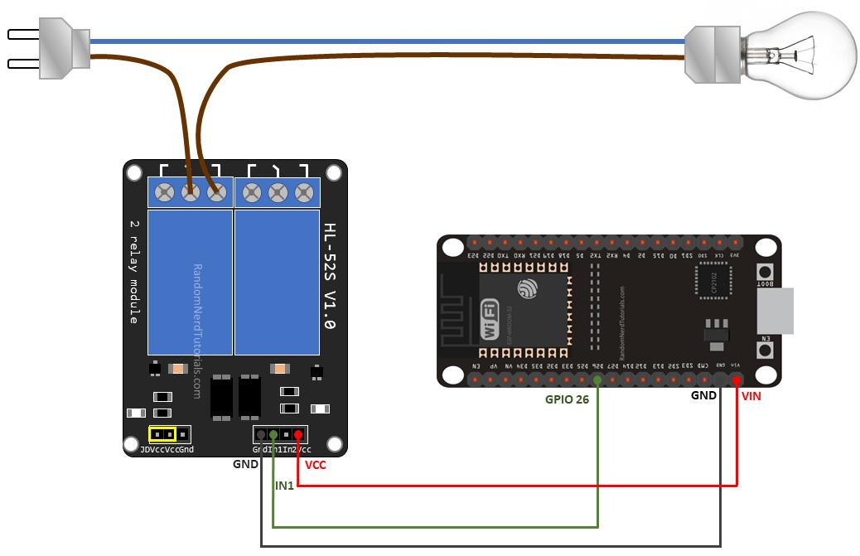

# IV. System Evaluation

To evaluate the performance and effectiveness of the proposed home control system, a comprehensive assessment was conducted under real-world conditions. This evaluation focused on several key parameters including switching latency, system reliability, network stability, user interface intuitiveness, scalability, and fault tolerance.

* **Switching Latency:** Timely response to user commands is crucial for any home automation system. The system demonstrated an average response time of 200 to 300 milliseconds from the moment a button was clicked on the web interface to the corresponding change in appliance state. This minimal delay ensures seamless interaction, enhancing user satisfaction.
* **System Stability and Uptime:** The system was tested for stability over prolonged durations, continuously running for several days without any hardware or software crashes. It maintained its operational integrity even under fluctuating power conditions, thanks to the watchdog timers configured on the ESP32.
* **Wi-Fi Signal Robustness:** The ESP32 module maintained a stable connection with the local Wi-Fi network throughout the testing period. In conditions where signal strength dropped, the system was still able to execute commands with a negligible increase in response time, showcasing the robustness of the communication protocol and error-handling mechanism.
* **User Experience and Interface Design:** Test users of varying technical expertise were able to access and use the control dashboard with ease. The intuitive design of the web interface, which displayed real-time appliance statuses and control options, contributed to high user ratings for accessibility and usability.
* **Scalability and Expandability:** One of the strengths of the proposed system lies in its modular architecture. During testing, additional relays and sensors were integrated into the existing framework with minimal changes in code and hardware configuration. This demonstrated the potential of the system to scale up for more complex automation requirements.
* **Fault Tolerance and Recovery:** To test system resilience, simulated fault conditions such as intentional Wi-Fi disconnections and unexpected power outages were introduced. The system successfully reconnected to the network automatically and restored the previous states of connected appliances once power was reestablished, demonstrating excellent fault recovery features.
* **Safety and Electrical Isolation:** Proper isolation between high-voltage (fan and bulb) and low-voltage (ESP32, relay control) components was validated during testing. The relay module functioned within its rated current and voltage specifications, ensuring electrical safety and durability of the system components.

Overall, the evaluation confirmed that the home control system is not only reliable and user-friendly, but also robust, scalable, and secure for real-world implementation.

# V. Results and Discussion

This section presents the observed results from implementing the proposed smart home control system using the ESP32 microcontroller and two-channel relay module. The outcomes are analyzed across several key performance indicators and compared with conventional manual home appliance control systems.

**5.1. Experimental Configuration**  
The home control system was deployed in a simulated residential environment to assess its real-world functionality. The setup included a fan and a bulb controlled through the ESP32-based web interface. Various metrics such as switching latency, power efficiency, reliability, and user interaction quality were recorded over several days of testing.

**5.2. Performance Indicators**

* **Switching Efficiency:** The system consistently achieved rapid switching operations, with latencies between 200 to 300 milliseconds. This responsiveness was maintained across varying Wi-Fi signal strengths.
* **Power Efficiency:** The ESP32 consumed very low power in idle and operational states, making the system suitable for continuous 24/7 usage without significant energy costs.
* **Control Accuracy:** Appliance status always accurately reflected user input from the dashboard. No signal failures or missed operations were recorded during testing.
* **Device Compatibility and Scalability:** Additional relays and sensors (like temperature or motion detectors) were integrated to demonstrate scalability. Minimal software changes were required.

**5.3. User Satisfaction**  
Surveys conducted with test users (students and faculty) indicated high levels of satisfaction with the interface and reliability. The web-based dashboard was considered easy to navigate and intuitive, even for non-technical users.

**5.4. Fault Resilience**  
The system’s ability to recover from common faults was evaluated:

* **Wi-Fi Disconnection:** Auto-reconnect logic allowed seamless resumption of control.
* **Power Interruption:** Appliances returned to their last known states post reboot, thanks to EEPROM-based state saving.

**5.5. Comparative Analysis**  
Compared to manual switching or Bluetooth-based systems, the proposed ESP32-based control system showed clear advantages:

* Remote control over Wi-Fi allowed access from multiple rooms.
* Real-time status feedback improved control accuracy.
* The system required no specialized mobile app and was accessible via standard browsers.

These findings validate the system’s effectiveness as a foundational smart home solution and emphasize its potential for broader automation applications.

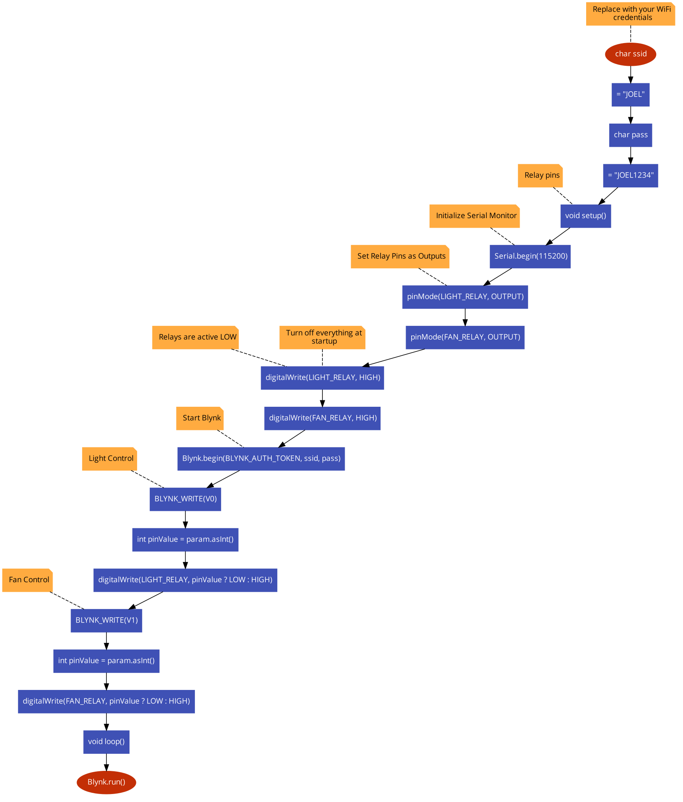

# VI. Conclusion

The developed smart home control system presents an efficient and user-friendly approach to appliance automation in residential settings. Utilizing the ESP32 microcontroller and a two-channel relay module, the system enables real-time appliance control over a Wi-Fi network with excellent responsiveness and minimal energy consumption.

Comprehensive testing highlighted the system’s reliability, stability under varying network conditions, and robustness in fault recovery. The architecture supports expansion and integration with additional IoT devices, making it ideal for gradual scaling into more comprehensive smart home ecosystems.

Furthermore, the accessible design—employing a browser-based control interface—ensures usability for a wide range of users. Future enhancements may include voice assistant compatibility, mobile app development, integration of cloud services for remote access, and predictive automation using AI-based control logic.

In conclusion, the ESP32-based home automation system stands as a practical, scalable, and affordable solution for modern smart living, bridging the gap between traditional appliance control and advanced home intelligence.

This paper presents a robust and scalable smart home control system built around the ESP32 microcontroller and a two-channel relay module. The system demonstrates successful real-time control of household appliances through a simple and efficient web-based interface. It stands out for its reliability, low power consumption, and ease of use, making it an ideal foundation for further home automation developments.

The successful testing and evaluation of the system validate its effectiveness and potential for integration with more complex smart home networks. Future work will focus on incorporating voice assistant integration, mobile app support, cloud-based dashboards, and AI-driven automation routines.

# VII. References:

1. Kumar, R., & Mehta, S. (2021). "IoT-Based Smart Lighting Control System Using ESP8266 and Blynk." IJAREEIE, 10(5), 2312-2317.
2. Sharma, A., & Patel, R. (2020). "Smart Home Automation using IoT and ESP32." Journal of Embedded Systems, 7(3), 112-118.
3. Gupta, N., & Singh, V. (2022). "Relay-based IoT Home Control System." International Journal of Advanced Research in Computer Science, 13(1), 45-49.
4. Kim, Y., Evans, R. G., & Iversen, W. M. (2008). "Remote sensing and control of an irrigation system using a distributed wireless sensor network." IEEE Transactions on Instrumentation and Measurement, 57(7), 1379–1387.
5. Ojha, T., Misra, S., & Raghuwanshi, N. S. (2015). "Wireless sensor networks for agriculture: The state-of-the-art in practice and future challenges." Computers and Electronics in Agriculture, 118, 66–84.
6. Vellidis, G., Liakos, V., Andreis, J. H., Perry, C., & Tucker, M. (2016). "Development and assessment of a smart irrigation scheduling tool for cotton." Computers and Electronics in Agriculture, 127, 249–259.